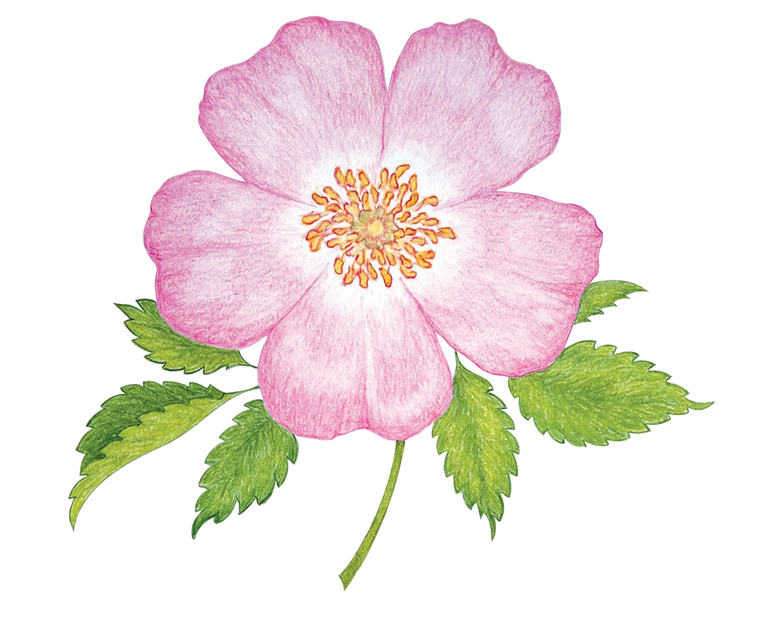

**Burlington Horticultural Society**

(Gardeners of Burlington)

Membership Form

____Renewal - Due November 1 ____New Member

____ $25.00 Single Membership ____$35.00 Family Membership

Membership fees cover the 12-month period from November 1 to October 31.

**For cheques**: make payable to ***Burlington Horticultural Society*** Mail your cheque and this form to

**BHS P.O. Box 91537, Burlington, Ontario L7R 4L6**

**For e-transfers:** If an e-transfer is your preferred payment method, use **burlhortsoc@gmail.com** and indicate your name in the notes section. Please email this form to the same

address.

Please Print your information below:

___Mr. ___Mrs. ___Ms. ___Miss ___Non-Gender Specific

Name(s): ____________________________________________________________________

Address: _____________________________________________________________________

City: _____________________________________ Postal Code: ___________________

Phone: ________________ Email address:______________________________________

I would be interested in being part of the volunteer team for: (please checkmark)

__ Marketing & Publicity __ Plant Sale __ Community Activities

__ Outreach Events __ Workshops

_____________________________________________________________________________

***For Office Use Only:***

Member # _________________ Amount Paid ________________

Cheque _________________ or Cash/e-transfer _________________

Media Release form signed: __ Yes __ No

Date: _______________________

Please note: All previous versions of this blank form are invalid as of January 15, 2025.